ACKNOWLEDGEMENT

First and foremost, I express my profound gratitude to Allah, the Most Merciful and Compassionate, whose boundless love and guidance ensured the success and safety of this journey. All praise belongs to Allah, and endless blessings be upon Prophet Muhammad (S.A.W.), the eternal source of wisdom and guidance for humanity.
I extend my sincere thanks to our esteemed teachers, whose dedication and assistance were crucial in making this trip a success. In particular, I am deeply grateful to Professor Dr. Md. Kamal Uddin, Dept. of Statistics, Islamic University, Kushtia, for his invaluable guidance and encouragement throughout this journey. This experience would have been harder without my teachers' support.
I would also like to offer heartfelt thanks to Professor Dr. Md. Mahabubur Rahman, Chairman of the Dept. of Statistics, Professor Dr. Md. Sazzad Hossain, Associate Professor Dr. Md. Shohel Rana, Assistant Professor Md. Matiur Rahman Molla, Assistant Professor Mst. Sifat Muntaha Sony, Assistant Professor Suman Biswas, and Silvia Khanam for their invaluable assistance during various aspects of the trip. Additionally, I am deeply thankful to Dr. Md. Shamimul Islam, Professor Dept. of Economics, Comilla University, for his insightful speech and guidance, which enriched our learning experience.
My sincere appreciation goes to all my friends who offered their help and companionship during the observation period. Lastly, I am profoundly grateful to my parents and family members, whose unwavering support, inspiration, and encouragement have been the foundation of my success. Their love and emotional support have been a constant source of strength throughout my academic journey.
Finally, I extend my apologies to anyone whose contributions I may have unintentionally overlooked. We deeply appreciate your assistance and support, in any form.

Md Tanvir Parvez
Department of Statistics
Islamic University, Kushtia, Bangladesh

ABSTRACT

A field trip offers an invaluable opportunity for participants to gain new knowledge by traveling to different locations. On February 27, 2024, our 10th batch students from the Department of Statistics at Islamic University, Kushtia embarked on an insightful field trip to the Bangladesh Academy for Rural Development (BARD).
The trip provided a deeper understanding of the challenges statisticians face in developing rural development models, the services offered by BARD, and the potential impact of the E-Parishad model on future population census methodologies. Furthermore, the trip included an exploration of various statistical methods currently applied in BARD’s operations.
In addition, we gained insights into the organizational structure of BARD, its mission and vision, and how its research facilities function to support sustainable rural development.
Keywords: BARD, Mission, Vision, Statistical Models.

Table of Contents
ACKNOWLEDGEMENT 1
ABSTRACT 2
Field Trip Examination Committee Members,2024 5
Chapter - 01: INTRODUCTION 6
1.1 Motivation 6
1.2 BARD (Bangladesh Academy for Rural Development) 7
1.3 Location of BARD 9
1.4 Transport 10
1.5 Purpose of Field Trip 11
1.6 Meaning and Objectives of the Field Trip 12
Chapter 02: History and Background 13
2.1 Founder of BARD 13
2.2 History of Bard 14
2.3 Cumilla Model 15
2.3.1 Components of Cumilla Model 15
2.3.2 Features of the Cumilla Model 15
2.3.3 Effectiveness of the Model 16
2.3.4 Difficulties of Comilla Model 16
Chaper-03: Ongoing research and training programs are being implemented at BARD 17
3.1 Functions of BARD 17
3.2 Training 17
3.2.1 Evolving the Training Focus and Curriculum at BARD 19
3.2.2 Participants of BARD’s Training Programs 21
3.2.3 Annual Training Calendar 21
3.2.4 Approaches to Training 22
3.2.5 Managing Training 22
3.3 Research 25
3.3.1 Research Approach and Execution 26
3.3.2 Research Funding and Partnerships 26
3.3.3 The Dissemination of Research Findings 27
3.4 Action Research 28
3.4.1 List of Research Proposals 29
3.4.2 Ongoing Research 29
3.4.3 Completed Research 32
3.4.4 Some Research Abstract 33
Chapter-04: Presentations Delivered by BARD Personnel 36
Introduction 36
4.1 First Session 36
4.1.1 Mandated Functions of BARD 36
4.1.2 Academic Divisions of BARD 38
4.1.3 Organogram of BARD 38
4.1.4 Service Division of BARD 39
4.1.5 Functions of BARD 39
4.1.6 Successful Rural Development Model 40
4.2 The Second Sessions 40
Chapter-05: Conclusion 42
Chapter-06: References 43

Field Trip Examination Committee Members,2024

- Professor Dr. Md. Mahabubur Rahman
Chairman, Department of Statistics, Islamic University, Kushtia
- Professor Dr. Md. Kamal Uddin
Examination committee Chairman, Department of Statistics, Islamic University, Kushtia
- Professor Dr. Md. Sazzad Hossain
Department of Statistics, Islamic University, Kushtia
- Associate Professor Dr. Md. Shohel Rana
Department of Statistics, Islamic University, Kushtia
- Assistant Professor Md. Matiur Rahman Molla
Department of Statistics, Islamic University, Kushtia
- Assistant Professor Sifat Muntaha Sony
Department of Statistics, Islamic University, Kushtia
- Assistant Professor Suman Biswas
Department of Statistics, Islamic University, Kushtia

Chapter - 01: INTRODUCTION

1.1 Motivation
Students in the second semester of the fourth year have recently completed the first semester of the fourth year. At fulfillment of the 1.5-credit course requirement for STAT-4109, our Department of Statistics at Islamic University, Kushtia, arranged an excursion to the Bangladesh Academy for Rural Development (BARD) in Kotbari, Cumilla. We, the fourth-year first-semester students, went on an educational excursion to BARD, an autonomous institution in Bangladesh known for its innovative contributions to rural development and policymaking. BARD, founded in the 1960s, achieved global acclaim for executing the Cumilla Model, a pivotal initiative in rural development for developing nations. Our seniors have previously visited several institutions, including BRRI, BARI, ICDDRB, and RDA. Therefore, we intend to visit a new location and choose BARD, Cumilla. Bangladesh possesses multiple rural development institutes, including the Bangladesh Academy for Rural Development (Cumilla), the Rural Development Academy (Bogura), abbreviated as RDA, and the Sheikh Hasina Rural Development Academy (Jamalpur). Following the liberation war, Bangabandhu Sheikh Mujibur Rahman founded the Rural Development Academy (RDA). We favor BARD for our field trip due to its status as the oldest organization among those listed. We were the first visitors from our department to the BARD, Cumilla. The motivation for attending BARD was to acquire new knowledge and experience.
BARD is committed to enhancing the socio-economic conditions of rural areas via its comprehensive research, training, and development initiatives. The purpose of the tour was to examine the methods of collecting, analyzing, and utilizing statistical data to assess the efficacy of rural development programs. To assess and enhance rural development initiatives, BARD uses several statistical methodologies, including two-stage and multistage sampling, as well as design strategies such as whole block design, randomized block design, and split-plot design.

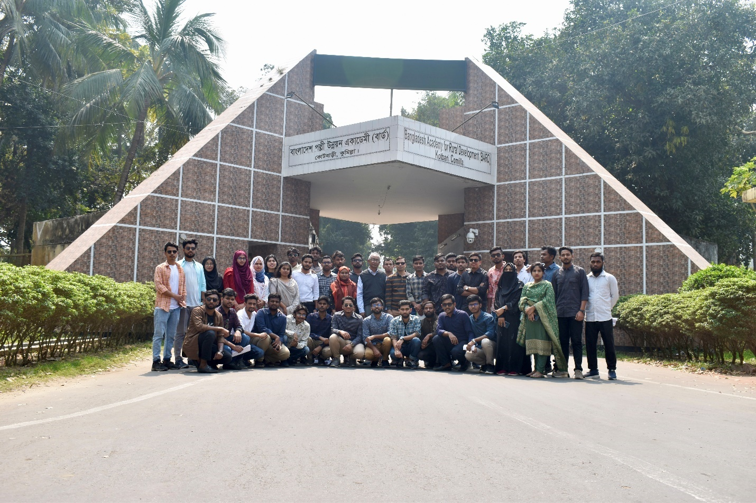

1.2 BARD (Bangladesh Academy for Rural Development)
The Bangladesh Academy for Rural Development (BARD), situated in Kotbari, Cumilla, is instrumental in promoting rural development in Bangladesh. Founded in the early 1960s by Dr. Akhter Hameed Khan, BARD has emerged as a premier institution committed to advancing rural development via research, training, and pragmatic initiatives. Dr. Khan conceptualized BARD as a center for knowledge generation and dissemination, promoting critical thinking and experimentation with creative concepts to enhance rural areas.
BARD is well-known for its application of the internationally acclaimed Cumilla Model, which prioritizes community engagement and grassroots participation. BARD, as an autonomous entity, provides a varied array of initiatives in agriculture, education, health, and infrastructure, integrating theoretical concepts with practical implementation.
Initiated in the 1960s, BARD's action research initiatives focus on evaluating innovative concepts in rural development, developed in partnership with specialists from Michigan State University. These initiatives, directed by Dr. Khan’s vision, utilize social science research to tackle administrative and developmental obstacles, persistently pursuing effective solutions for rural transformation.
BARD has significantly contributed to rural development in Bangladesh through its creative research and practical activities. Its efforts have been pivotal in transforming innovative concepts into significant solutions, establishing it as a crucial contributor to the nation's overarching development objectives and enhancing rural areas nationwide.
A dynamic process known as globalization, it enhances trade and commerce, thereby diminishing the importance of national borders in the global economy. Its consequences differ among individuals, groups, and nations, influencing economic growth, financial flows, technological access, democratic governance, and cultural dynamics. The core of this discussion is the notion of “Access to Influence,” which denotes the capacity to alter conditions—whether economic, political, or social—and attain objectives through the proficient use of resources, governance frameworks, and institutions. The inequity in access to vital organizations and procedures within the developing global framework has garnered heightened examination.
In today’s world, both advanced and developing countries are navigating the complexities of globalization, and Bangladesh is no exception. With a population of approximately 161 million, about 75% of whom live in rural areas, the country faces significant challenges related to rural development, making it a vital issue for social inclusion. The Bangladesh Academy for Rural Development (BARD) is a government organization established to promote rural development through research, training, and action-oriented initiatives.
Founded by Dr. Akhter Hameed Khan, BARD serves as a training institute that fosters rural development by collecting and disseminating knowledge while promoting critical thinking and innovation. The Academy’s action research program began in the 1960s, focusing on the application of social sciences to address administrative challenges. Recognized for its contributions to transforming innovative ideas into practical solutions, BARD operates under the BARD ACT of 2017, enabling it to analyze village-level issues, launch action research initiatives, and implement various projects funded by the Annual Development Program.

1.3 Location of BARD
The Bangladesh Academy for Rural Development (BARD) is located in Kotbari, approximately 10 kilometers from Cumilla town. Spanning 156 acres of picturesque natural surroundings, the BARD campus offers a wide array of facilities. These include residential quarters, conference rooms, a mosque, a library, a health clinic, a sports complex, and other essential amenities, creating a comprehensive environment for learning, research, and development activities.

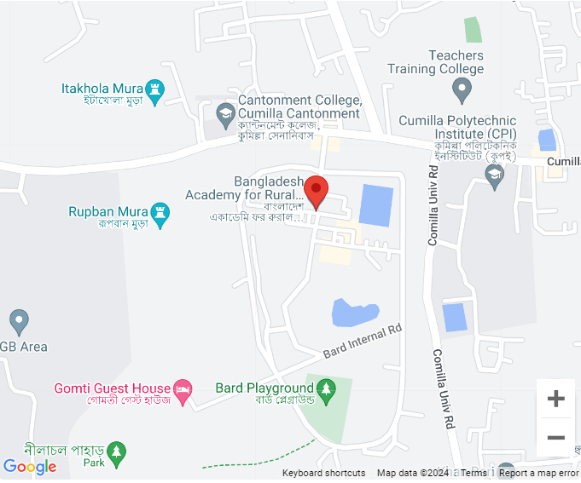

1.4 Transport
We arranged for a bus to transport us from the campus. The bus was visually appealing, but the seating quality left something to be desired. Each passenger had limited space, which was somewhat uncomfortable. However, the driver was exceptionally patient and accommodating, making the journey more pleasant.

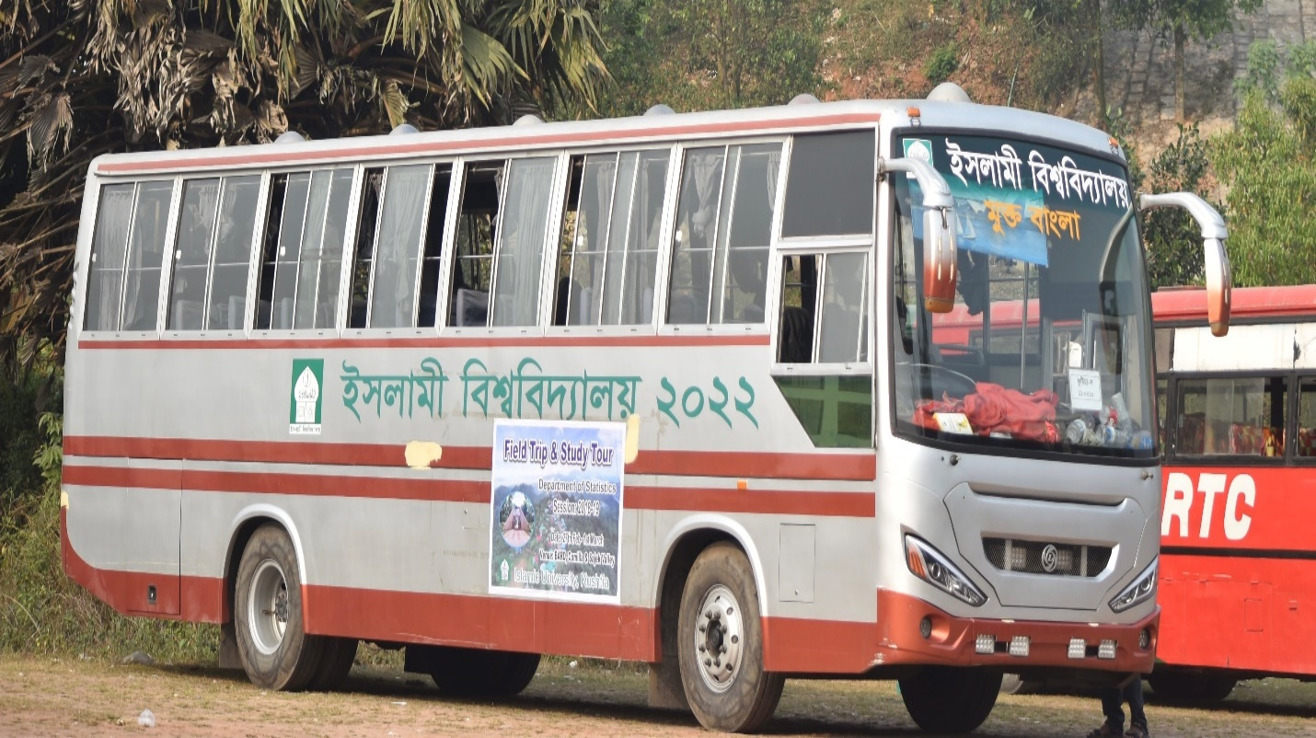

1.5 Purpose of Field Trip
- To visit BARD (Cumilla) and gain a comprehensive understanding of the statistical procedures and methodologies they implement in their research and development initiatives.
- To observe the practical applications of statistical techniques in addressing rural development challenges and improving community welfare.
- To interact with professionals at BARD and learn about their approaches to data collection, analysis, and interpretation in various projects.
- To enhance our knowledge of how statistical theories are applied in real-world scenarios, particularly in rural development contexts.
- To foster collaboration and communication among students, enhancing our learning experience through shared observations and insights.
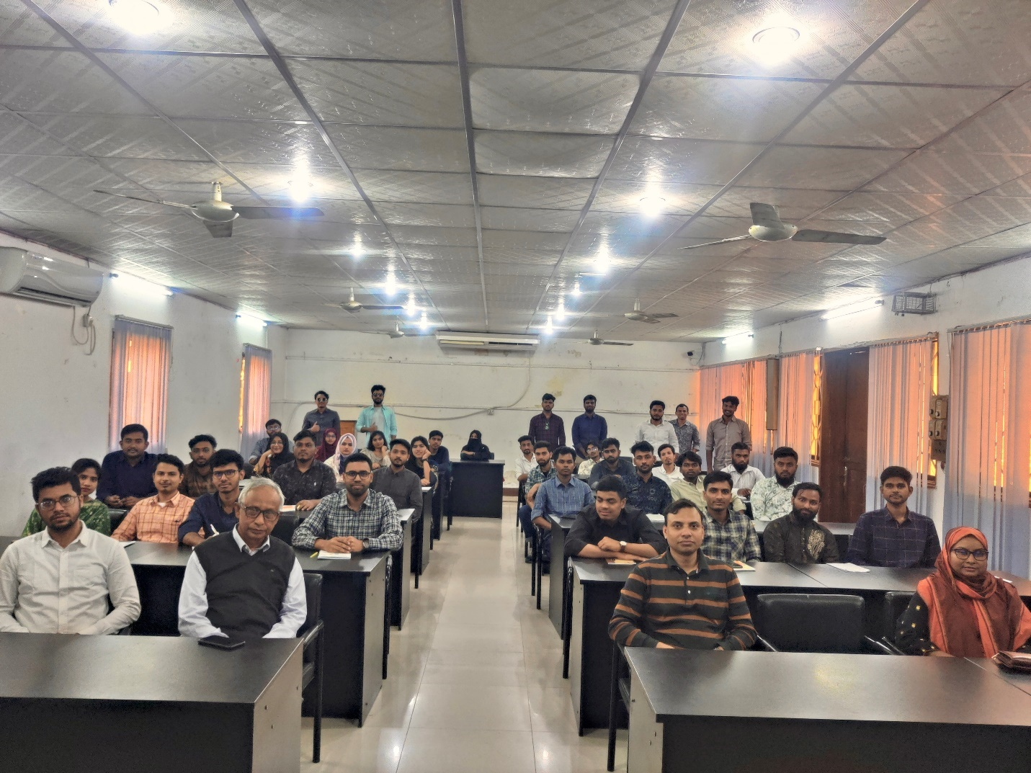

1.6 Meaning and Objectives of the Field Trip
A field trip is an educational outing that takes students or participants beyond their usual classroom setting to explore and learn in various environments. This experiential learning opportunity allows participants to engage directly with the subject matter, making learning more dynamic and impactful.
The objectives of a field trip can vary widely, but some key purposes include:
- Enhancing Learning: Field trips provide hands-on experiences that deepen understanding of specific topics, making theoretical concepts more tangible and easier to grasp.
- Experiencing Real-World Applications: They showcase how academic knowledge is applied in real-world situations, helping students bridge the gap between classroom theory and practical implementation.
- Encouraging Observation and Exploration: Field visits stimulate curiosity and critical thinking by encouraging participants to observe their surroundings and actively engage with the environment.
- Developing Social Skills: Interacting with peers and educators in diverse settings fosters teamwork and communication skills, essential for both personal growth and professional development.
- Cultural and Historical Awareness: Trips to museums, historical sites, or cultural landmarks expose participants to various cultures and histories, enriching their educational experience.
- Promoting Environmental Consciousness: Visits to nature reserves or ecological sites raise awareness of environmental issues and the importance of sustainability and conservation.
- Career Awareness: Some field trips provide insights into potential career paths by allowing students to visit different industries or organizations, aiding in career exploration.
- Increasing Engagement and Enjoyment: Field trips break the monotony of traditional learning, making education more enjoyable and memorable, which can enhance motivation and interest in the subject matter.
Overall, the primary aim of a field trip is to enrich classroom learning by providing real-world experiences and insights that lead to improved educational outcomes.

Chapter 02: History and Background

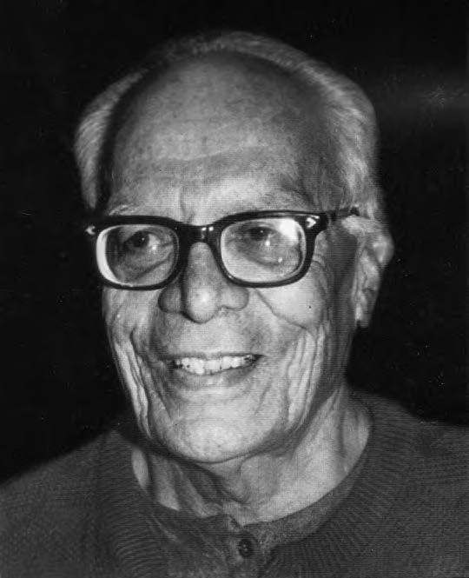
2.1 Founder of BARD
BARD was established in 1959 in Comilla by the Pakistan Academy for Rural Development. Dr. Akhter Hameed Khan (1914–1999) was the founder Director of BARD. Khan was born on 15 July 1914 in Agra. He was among the four sons and three daughters of Khansaahib Ameer Ahmed Khan and Mehmoodah Begum.[1] His father, a police inspector, was inspired by the reformist thinking of Syed Ahmed Khan. In his early age, Khan's mother introduced him to the poetry of Maulana Hali and Muhammad Iqbal, the sermons of Abul Kalam Azad, and the Sufist philosophy of Rumi. This upbringing influenced his interest in historical as well as contemporary social, economic, and political affairs.
Khan became principal of Victoria College in Comilla, East Pakistan (now Bangladesh) in 1950. As a substitute for donations, Khan created a Karkhana (workshop) to empower the needy the same year. Khan believed that self-reliance was the key to success, and that communities should build strength so that individuals could own their futures. He founded a cooperative workshop where people owned and managed production. Initial production included padlocks and paper weights, but later it covered manufacture, research, and training.
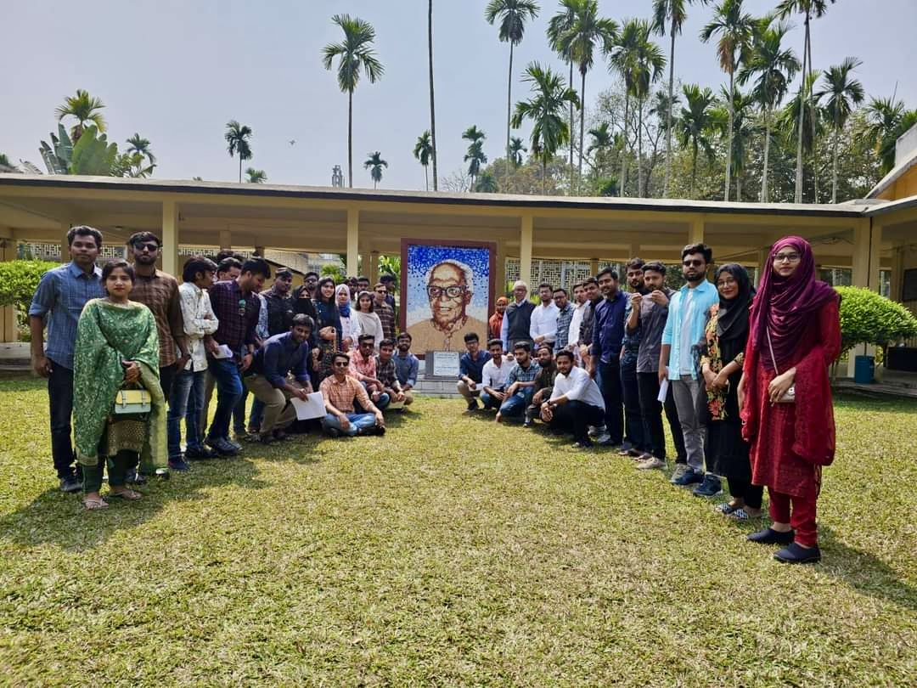

2.2 History of Bard
Dr. Akhtar Hameed Khan, the institution's first director, oversaw the establishment of the Bangladesh Academy for Rural Development (BARD) as the East Pakistan Academy for Rural Development in Comilla in 1959. Following Bangladesh's independence, the institution adopted its current name. BARD commenced operations on May 27, 1959, concentrating on training, research, and action research to promote rural development.
BARD's notable contribution is the creation of the Comilla Model, an integrated strategy that amalgamates cooperative agriculture techniques, local administration, and infrastructure development. This strategy has received global recognition and acts as a prototype for rural development projects in Bangladesh and other developing nations.
During its initial years, BARD focused on research and pilot initiatives aimed at augmenting agricultural productivity, enhancing education and healthcare, and empowering local communities through cooperative frameworks. It gradually broadened its focus to encompass capacity building and training for government officials, rural leaders, and development practitioners, highlighting community engagement and self-sufficiency.
BARD has had a profound impact on Bangladesh's rural development policies, aiding national plans for poverty reduction and rural progress. The institution persistently tackles rural development concerns via innovative solutions and functions as a pivotal hub for research, training, and policy advocacy.
BARD, with its significant expertise in rural development, is a vital resource for understanding and addressing the intricate socio-economic challenges confronting rural Bangladesh. BARD dedicates itself to advancing sustainable development through participatory methods, capacity enhancement, and evidence-driven solutions.
The Minister for Local Government, Rural Development, and Cooperatives chairs the Board of Governors, which currently oversees BARD. The Board establishes institutional policies, whereas the Director General, supported by an Additional Director General, oversees daily operations and policy execution.
BARD comprises nine sections, encompassing both service and academic sectors. The service departments include research, training, projects, and administration, while the academic divisions concentrate on rural sociology, rural economics, rural administration, agricultural development, and rural education. 305 professionals assist the academy, which employs 60 teaching members and conducts pilot projects to develop reproducible models for agriculture, rural administration, cooperatives, community health, and initiatives for youth and women.
BARD significantly contributes to rural Bangladesh's advancement through innovative research, training initiatives, and action research endeavors.

2.3 Cumilla Model

2.3.1 Components of Cumilla Model
The components of Comilla Model are as follows:
- Two tier cooperatives - Krishak Samabaya Samity (KSS, i.e. farmers’ cooperative association and
- Thana Central Cooperatives Association (TCCA)
- Rural Works Program (RWP)
- Thana Irrigation Program (TIP).
- Thana Training and Development Centre (TTDC)

2.3.2 Features of the Cumilla Model
The salient features of the Cumilla Model may be identified as:
- The promotion of development and of refining of various institutions, both public and private, and establishing a system of interrelationships between them;
- Involvement of both public and private sectors in the process of rural development;
- Development of leadership in every village, including managers, model farmers, women organizers, youth leaders, and village accountants, to manage and sustain the development efforts;
- Development of three basic infrastructures (administrative, physical and organizational);
- Priority on decentralized and coordinated rural administration in co-ordination with officials of various government departments and the representatives of public organizations.
- Integration and co-ordination of the various developing services, institutions and projects;
- Education, organization and discipline;
- Economic planning and technology;
- Development of a stable and progressive agriculture to improve the conditions of the farmers, and provide employment to rural labor force.

2.3.3 Effectiveness of the Model
- It has replaced the old colonial approach – ‘development through officers’.
- It has solved some critical problems like low agricultural productivity, food deficit, rural unemployment etc.
- The farmers can be organized for production,
- Investment can be made in rural area,
- Leadership can be developed in rural areas,
- Large scale adoption of technological innovations can take place in rural communities,
- The rural people and government can work as partners, and
- A bottom-up planning can be introduced.
The models have evolved a combination of training knowledge-communications systems

2.3.4 Difficulties of Comilla Model
For various reasons the Comilla Model was unable to achieve its goal. It had particular troubles with government relations and efforts to build strong cooperative institutions. According to Dr. Khan “… in actual practice, the four programs suffered from-
- Distortion
- Mismanagement
- Corruption and
- Subversion

Chaper-03: Ongoing research and training programs are being implemented at BARD

3.1 Functions of BARD
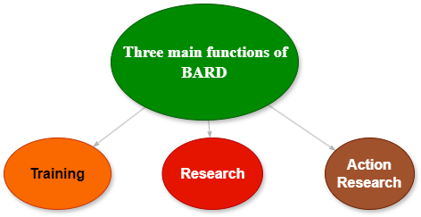

3.2 Training
The transformation of Bangladesh from a developing country to a middle-income nation has required systematic changes in its production, distribution, and service delivery systems. In this journey, human resources have played a crucial role. In line with evolving policies both domestically and internationally, Bangladesh's perspective plan emphasizes the utilization of labor from poor and disadvantaged families, aiming to increase productivity and enhance the professionalism and commitment of civil servants. Additionally, it seeks to strengthen the capacity of local governments, particularly in exercising fiscal authority.
The essence of the Sustainable Development Goals (SDGs) has shifted global focus from mere quantitative measures to qualitative changes, highlighting the need for productive and decent employment. This also includes the creation of accountable, transparent, and effective service delivery institutions within the government sector. Training has emerged as a vital tool for improving productivity and building capacity by transferring technology, sharing modern management techniques, and addressing the administrative, legal, social, and political realities that influence service delivery mechanisms.

Since its inception in 1959, the Bangladesh Academy for Rural Development (BARD) has been dedicated to training various development functionaries, including government and non-government officials, as well as leaders and members of community organizations and local government institutions. Training is a core component of BARD's mission, complemented by research and action research that ensure its programs are pragmatic and effective. Dr. Akhter Hameed Khan, the renowned social scientist and founding director of BARD, introduced these innovative approaches, and the Academy has consistently upheld this tradition. From 1959 to the present, BARD has conducted a total of 9,043 courses, benefiting 310,736 participants.
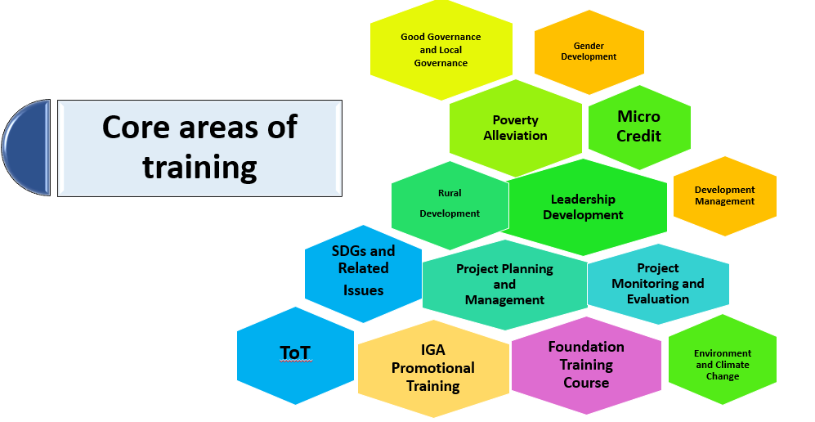
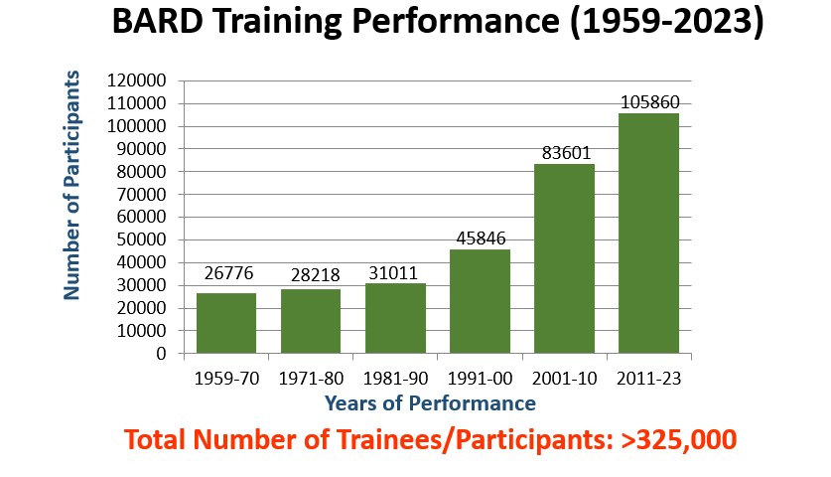

3.2.1 Evolving the Training Focus and Curriculum at BARD
BARD is a prestigious training institute within the public sector. As an autonomous organization, it is tasked with designing its training programs to address the diverse needs of various client groups, while also aligning with both domestic and international policy priorities. Since its inception, BARD has prioritized curriculum-based training, specifically tailored to fulfill the training requirements of Village Agricultural and Industrial Development.

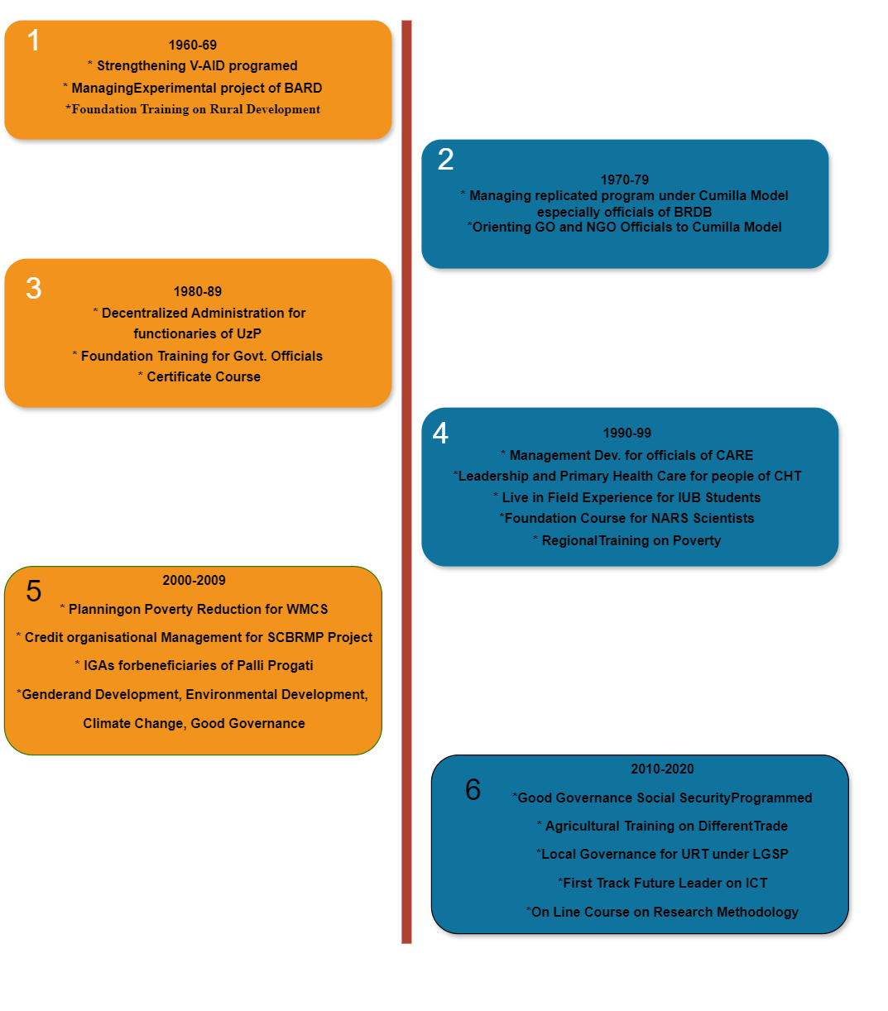
In the early 1960s, BARD focused on building the capacity of Village Agricultural and Industrial Development (V-AID) program implementers. Concurrently, it experimented with innovative development concepts in its social laboratory areas. After seeing promising results, the government decided to expand these programs, leading to the Academy's involvement in training project managers on managing experimental projects.
BARD was also tasked with designing a Foundation Training Course on Rural Development for civil servants. The four components of the Cumilla model, pioneered by BARD, were replicated nationwide in the late 1960s and early 1970s. During this time, the Academy focused on training government and non-government officials on the organizational and managerial aspects of the Cumilla model.
By the 1980s, the training demand for the Cumilla model began to decline. The introduction of the Upazila system created a new opportunity to train elected representatives and officials of Upazila Parishads. BARD also expanded its training offerings to include contemporary development issues for both government and non-government officials. In addition, foundation training for newly recruited government officials became a significant focus, signaling a shift in BARD's training policy.
From 2000 to 2009, BARD developed new training programs addressing issues such as poverty reduction, gender and development, environmental sustainability, climate change, and good governance. The Academy also began offering training on project management, social security programs, and online research methodology courses, reflecting an evolving focus.
Between 2010 and 2020, BARD continued to adapt its curriculum, introducing courses on good governance, agricultural training, local governance under the Local Government Support Project (LGSP), and fast-track leadership programs focusing on ICT. BARD also provided foundation training for health officials, attachment courses for various cadre service officers, and regional training under the auspices of organizations like AARDO.
During this time, BARD played a pivotal role in training local government officials in the Chattogram and Sylhet divisions, as well as organizing short courses on poverty, governance, social security, gender, and office management for stakeholders involved in donor-funded projects. The Academy also embraced ICT advancements by offering relevant training programs.
Over the last several years, BARD has concentrated on providing foundation training for various cadre officials and agricultural training for beneficiaries of projects like Amar Bari Amar Khamar and Lalmai Moynamoti. These efforts reflect BARD's adaptability to changing national priorities and market demands.
Throughout the decades, BARD’s training curriculum has evolved significantly. Shifts in government policy, national priorities, market demands, and faculty expertise have all played crucial roles in shaping the curriculum.
In the 1970s, BARD faculty worked tirelessly to train officials on implementing experimental projects. However, by the 21st century, two major projects—the Comprehensive Village Development Programme (CVDP) and Small Farmers Development Programme (SFDP)—were handed over for wide replication. While BARD continued organizing training for officials involved in these projects, the long-term insights gained from years of experimentation were not fully infused into the training programs for implementing officials.

3.2.2 Participants of BARD’s Training Programs
Civil servants, development officials, leaders of village institutions, local government representatives, and university students are the primary participants in BARD's training programs. The Bangladesh Public Administration Training Centre (BPATC) regularly sends its Foundation Training Course participants to BARD for practical exposure to rural livelihoods. Each year, BARD collaborates with various sponsoring agencies to organize training sessions for its target audience.
As market demands, policies, and technologies evolve, BARD continually adapts its training content, allowing for innovative and competitive program designs. Recently, BARD has trained participants from organizations like DGHS, LGED, MoPA, MoWCA, BARC, MJF, WDB, and AARDO. There's also been a rising interest from university students, particularly from Bangladesh University of Professionals (BUP) and the University of Chittagong. Last year, new participants from organizations such as RAJUK, BRDB, WDB, CBHC, LDDP, NAEM, NAPD, BPATC, and the Totthoapa Project joined the training programs.

3.2.3 Annual Training Calendar
Annually, subsequent to the Annual Planning Conference (APC), BARD publishes an extensive training calendar detailing the programs planned for the year. These programs are developed in response to requests from sponsoring agencies and encompass self-initiated training courses, workshops, seminars, and sessions funded by national and international organizations.
BARD is adaptable and can fulfill supplementary training requests from other institutions, contingent upon the Academy's available capacity, in addition to the established calendar.

3.2.4 Approaches to Training
The correct and methodical application of various approaches and resources is crucial to the success of any training program. Over the years, BARD has refined and upgraded its training methods to increase participation and maximize the educational experience. There has been a recent push from the government to replace PowerPoint lectures with more interactive and collaborative approaches. As a result, BARD has been increasing the use of interactive methods like lecture-cum-discussion, group discussions, exercises, seminars, workshops, brainstorming, syndicates, field attachments, surveys, book reviews, case studies, report presentations, games, simulations, debates, role plays, and documentary film screenings.
In addition, video conferencing has been implemented to allow for direct communication with specialists and representatives from other groups. Under the direction of the Director General, BARD has coordinated multiple online discussion forums. Notable video conferences with RDCD representatives were held last year, giving IGA Training Course attendees a chance to voice their opinions. Also, with the use of the Zoom platform, several sessions featuring renowned resource persons were held for sponsored programs such as Foundation Training Courses (FTC), Special Foundation Training Courses (SFTC), and others.

3.2.5 Managing Training
BARD's training activities are comprehensively coordinated by the Training Division. The Director is the head of this Division, with the assistance of a Joint Director, Deputy Director, and Assistant Director. Additionally, support personnel, such as a Section Officer, Training Officer, and other personnel, contribute to the management of daily operations. The Division is responsible for the following: the supervision of regular communication and negotiations with sponsoring organizations, the organization of training courses, the preparation of budgets and schedules, and the timely release of funds. The Division proposes the Course Administration for each training program in the annual plan, which is subsequently approved by the Director General to ensure the program's seamless implementation.
BARD effectively conducted 215 training courses during the fiscal year 2022-23, surpassing the target of 137 courses. The number of participants exceeded the objective of 5,919. We reached 9,724. This is an extraordinary accomplishment, as it demonstrates a 157% improvement in course organization and a 164% increase in participant numbers. 60% of the participants were male, while 40% were female.
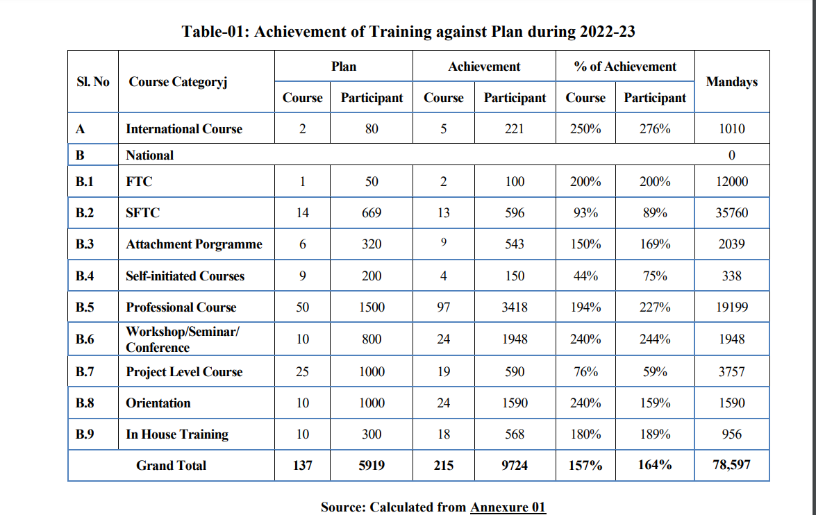

A cumulative total of 78,597 man-days was expended on training activities over the 2022-23 period. Upon detailed examination, it is apparent that the predominant allocation of man-days was directed towards Special Foundation Training Courses (45.50%), Professional Courses (24.43%), and Foundation Training Courses (15.27%). A concise summary of the various training modalities is presented here.
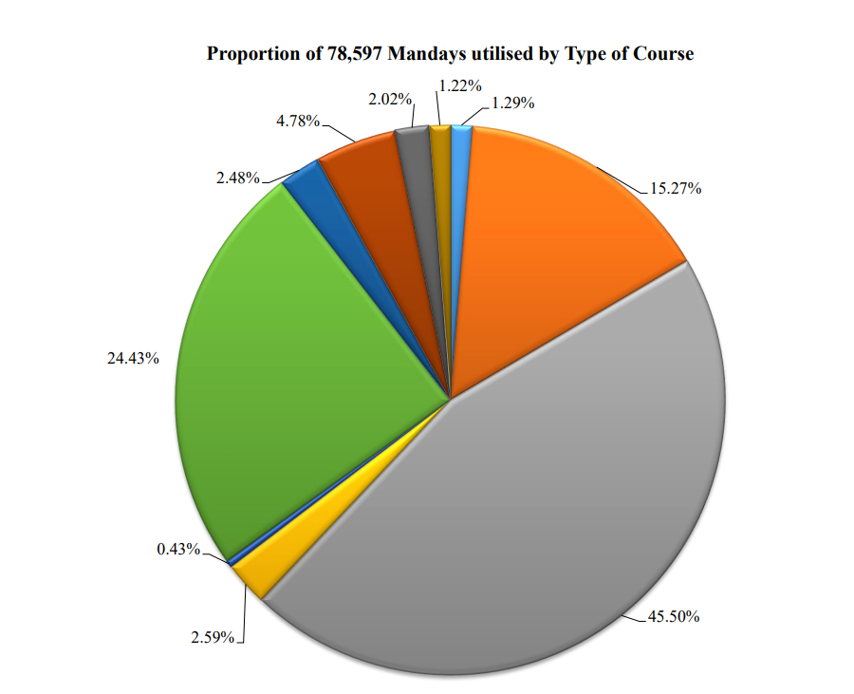

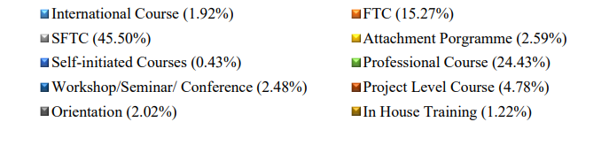

3.3 Research
The Bangladesh Academy for Rural Development (BARD) has been an important fulcrum for fruitful rural development studies ever since it was founded. Many well-known rural development projects in Bangladesh may be traced back to the suggestions given by BARD researchers in the 1960s and 1970s; the organization has carried out 722 investigations across many domains since 1959. Knowledge creation, theory refinement, and the identification of effective solutions to critical societal concerns are all greatly aided by the research conducted at BARD.
A core responsibility of the Academy is to support viable and sustainable rural development, prioritizing the engagement of rural communities in development efforts and addressing their challenges from their perspectives. Feedback from the rural poor is particularly valued in BARD's research endeavors. The Academy emphasizes action-oriented research, exemplified by the influential “Comilla Model,” which transformed the agricultural landscape of the country.
BARD's research programs analyze existing initiatives to enhance their effectiveness. The findings from research and pilot projects yield crucial data for policymakers, aiding the formulation of impactful rural development strategies. Faculty members utilize these research insights as instructional resources, enriching the Academy’s training programs. This approach enhances participants’ understanding of the realities in rural areas, equipping them with the knowledge to tackle challenges effectively.
Research is central to BARD’s mission of benefiting rural communities. Its research culture establishes BARD as a leader in rural development, propelling knowledge and innovation to new heights. The emphasis on the significance of research not only reflects a core belief but also showcases BARD’s unwavering commitment to fostering a brighter and more prosperous future for rural Bangladesh.
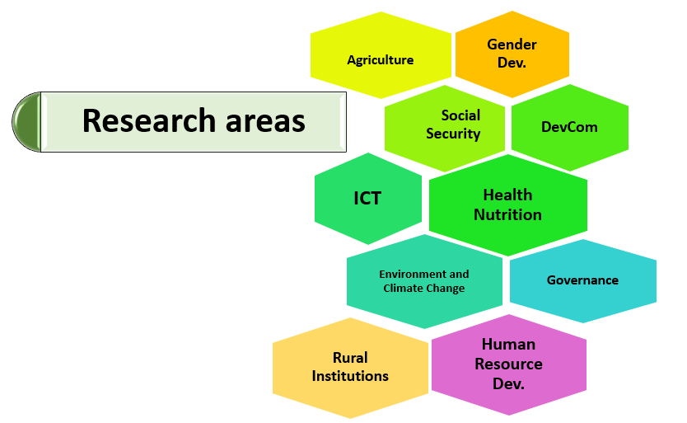
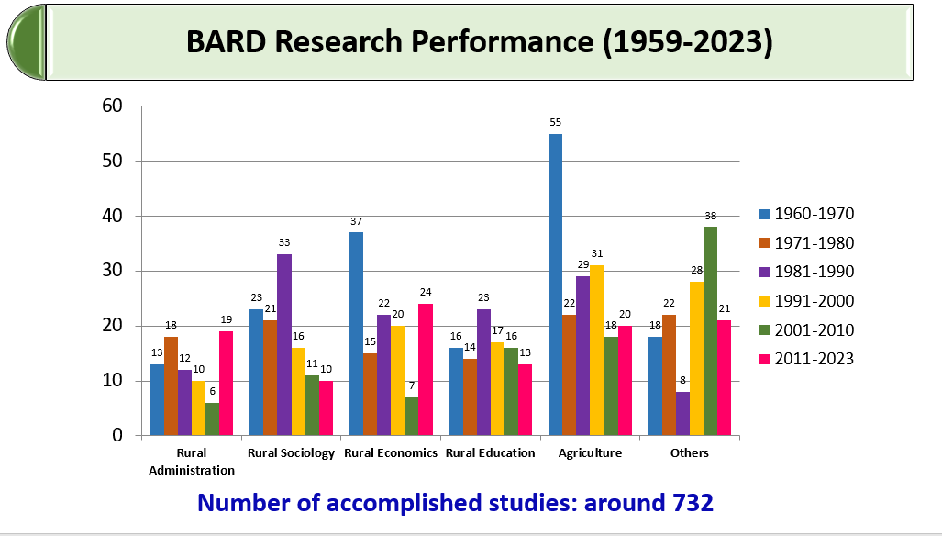

3.3.1 Research Approach and Execution
The research process at BARD commences with the submission of a proposal to the research division and culminates in the publication of findings. Faculty members undertake annual research projects focusing on socioeconomic issues relevant to their areas of expertise. The research division plays a crucial role in coordinating these activities, offering intellectual, collaborative, and logistical support to researchers. Comprising 25 dedicated staff members, the research division operates as a specialized service unit, ensuring the effective implementation of BARD’s research initiatives.

3.3.2 Research Funding and Partnerships
BARD’s research initiatives primarily depend on funding from the government. In addition to this, the Academy engages in collaborative research projects supported by financial contributions from various national and international donor organizations.

3.3.3 The Dissemination of Research Findings
BARD conducts 10 research initiatives annually to address the urgent issues of rural development. These studies offer critical grassroots insights into rural challenges, their underlying causes, and feasible remedies, thereby arming policymakers with the requisite knowledge for informed decision-making.
The findings from these research initiatives are disseminated through various platforms, including seminars, workshops, and training sessions. One of the hallmark events hosted by BARD is the annual “Research Highlights,” where research outcomes are presented to fellow scholars, policymakers, and stakeholders. The latest Research Highlights event took place in June 2023, showcasing discussions on seven recently completed studies, fostering a rich exchange of ideas and knowledge.
To further ensure the effective communication of its research results, the Academy publishes a range of materials, including papers, bulletins, and academic journals. This comprehensive approach to dissemination not only enhances the visibility of BARD's research but also encourages collaboration and dialogue across different sectors involved in rural development.

3.4 Action Research
BARD's experimental programs develop institutional, administrative, coordinating, and production process models. These projects generally entail cooperation with villages, development organizations, local councils, and government authorities. As of now, the Academy has implemented around 74 experimental initiatives in various areas of rural development. Through these pilot experiments, BARD has formulated multiple rural development models that have been extensively duplicated nationwide as part of the Cumilla Model:
- Two-tier cooperatives
- Thana Training and Development Centre (TTDC), renamed Upazila
- Rural Works Programme (RWP)
- The Thana (now Upazila) Irrigation Program (TIP)

Furthermore, the government has been emulating two of BARD's latest models: the Comprehensive Village Development Programme (CVDP) and Ecological Sanitation. The Small Farmers Development Foundation (SFDF) represents a current approach.

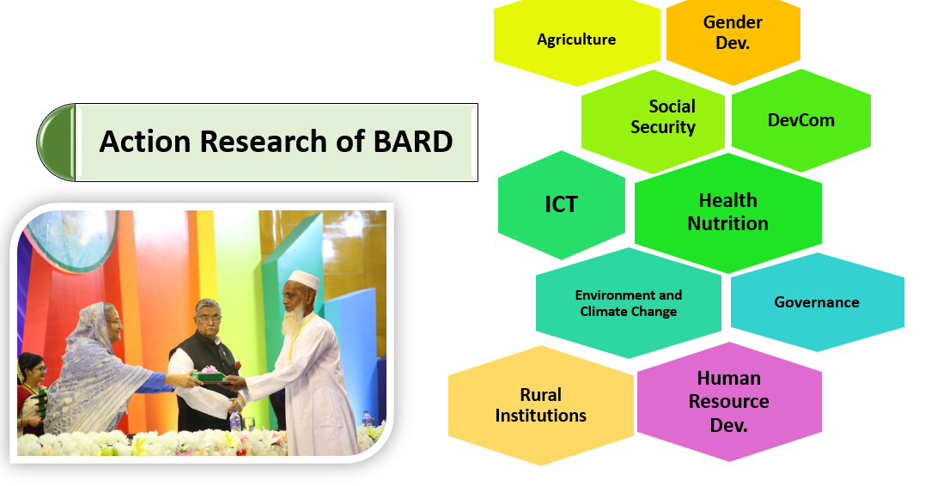

3.4.1 List of Research Proposals
During the fiscal year 2022-2023, more than two dozen research studies were in progress, encompassing both new initiatives and ongoing programs from previous years. The 55th Annual Planning Conference generated proposals that sparked investigations into specific issues. Consequently, some of these recommended studies were initiated, while others were integrated into existing research projects. The table below summarizes the discussions and recommendations made by participants:

3.4.2 Ongoing Research
SI No. | Research Title
1. | Land Tenure, Crop Choice and Land Productivity: Recent Change in Rural Bangladesh
2. | Cultivable Land Use Pattern by Absentee Landowner in Sylhet: A Case of Three Villages
3. | Potentials of Women in Agricultural Entrepreneurship in Bangladesh
4. | Effectiveness of Training Courses of CVDP (renamed)
5. | The 4th Industrial Revolution (4IR) and the Changing Patterns of Employment: Readiness of Rural Youth in Bangladesh
6. | Ailless Agricultural Mechanization and Collective Farm Management: An Appraisal in the Light of Bard's Empirical Research
7. | Occupational Diversification of Rural Women: Trends in the Last Three Decades
8. | Impact of Regulation on the Microfinance Sector of Bangladesh
9. | Dairy and Beef Farming Scenario in selected Areas of Cumilla and Brahmanbaria District.
10. | Community Driven Development (CDD) Approaches and Opportunities of People's Participation: Problems and Prospects in Chittagong Hill Tracts of Bangladesh
11. | Information and Communication Technologies in Agricultural development in some selected areas of Bangladesh.
12. | From Crisis to Resilience: Analyzing the Impact of Covid-19 on Rural Livelihoods in Bangladesh
13. | Life and Livelihood: A Development Survey, Committed deadline for submission: 31/10/2021
14. | Agroforestry in Achieving Food Security of upland smallholders: A Case on Lalmai Hill Areas of Cumilla District.
15. | Dynamics of Migration at the Household Level in Three Villages
16. | Farmer's Knowledge, attitude and practice of mastitis in Cow
17. | Adoption and Integration of ICT by Secondary School Teachers in Rural Schools of Bangladesh: An Analysis Using the Technology Acceptance Model (TAM).
18. | Inclusive Education and Training Towards Autism for Empowerment: A Sociological Study of Selected Villages.
19. | Climate Change Effects on the Coastal Livelihoods: A Case of South-Western Bangladesh.
20. | Potentialities and Strategies of Public Private Partnership in Rural Development of Bangladesh.
21. | Family and Human Development Aspirations: Socialization at Bangladesh Transforming Villages.
22. | Village Court and its Potentialities in Grievances Reduction of Bangladesh

3.4.3 Completed Research
SI No. | Research Title
1. | Village Court and its Potentialities in Grievances Reduction of Bangladesh
2. | Role of Agricultural cooperatives in Ensuring Farmer’s Wellbeing: Cases of some Selected Areas of Bangladesh
3. | Livelihood and Social Inclusion Pattern of the Migratory Labourers: Cases of Five Districts of Bangladesh
4. | Sustainability of Digital Service Centers: A Case of Union Digital Centers (UDCs) in Bangladesh
5. | Governance through Gram Committee in Participatory Rural Development Project in Bangladesh
6. | Nature of poverty in Kurigram and Gopalganj districts: Remedy and development
7. | Impact of COVID-19 Pandemic on Rural Livelihood
8. | Rural Transforming and Social Wellbeing of Selected Villages in Bangladesh
9. | Present Conditions of Homestead Plantation in Cumilla: A Case Study of Four Villages

3.4.4 Some Research Abstract
- Livelihood and Social Inclusion Pattern of the Migratory Labourers living in Cumilla District
Salahuddin Ibne Syed, Joint Director, BARD
Junaed Rahim, Deputy Director, BARD
Kazi Foyez Ahmed, Assistant Director, BARD

Abstract
Bangladesh remains predominantly agrarian, with 65% of the population living in rural areas and 40.6% employed in agriculture (BBS 2017). Internal migration of laborers is common and a policy concern, as it drives economic growth while also contributing to urban deprivation and the disruption of traditional rural life. This study examines the dimensions and impacts of internal migration, particularly from northern districts like Lalmonirhat, Thakurgaon, Kurigram, and Nilfamari to regions like Cumilla.
The study's primary aim is to analyze changes in demographics and livelihoods due to migration. Specific objectives include examining the causes of migration, the livelihood patterns of migrants, and their involvement in income generation. Both qualitative and quantitative methods were used, with 250 migratory laborers interviewed. The majority were aged 21-40 and motivated by poverty and lack of work in their home districts. After migrating, many saw their working days increase significantly, with 30% working more than 300 days annually. Most earned between Tk 201-400 per day.
Key issues faced by migrants included poor accommodation and sanitation. Despite these challenges, many improved their savings habits and adopted cooperative methods. The study recommends creating more job opportunities in northern districts, developing infrastructure, offering incentives for migrants, and establishing agro-based industries to reduce migration pressures. Government and non-government efforts should focus on sustainable poverty reduction through local development and employment creation.

- Impact of COVID 19 Pandemic on Rural Livelihood
Abdullah Al Hussain, Deputy Director, BARD
Kamrul Hasan, Assistant Director, BARD
Anas al Islam, Assistant Director, BARD

Abstract
This study, conducted in July 2020, aimed to assess the immediate impact of the COVID-19 pandemic on rural livelihoods and how people managed the crisis. Data collection took place in August and September 2020, using a mixed-method approach to survey 332 rural households across three upazilas in Cumilla district. The findings highlight a variety of coping mechanisms and offer a comparative view of the support provided by the government, individuals, and non-governmental organizations.
The study identified two key factors that contributed to rural resilience: individual adaptability and community support. The strong social bonds in rural areas served as a significant asset, helping mitigate the anticipated losses at the household level. While the pandemic's economic effects were less severe than expected, it severely impacted students, particularly those in primary and secondary schools. The disruption in education may have long-term consequences, and without substantial policy interventions, the academic setbacks faced by rural children could have significant future implications for the nation.

- Cost Benefit Analysis of Mechanized and Labor-Intensive Production of Major Crops
Abul Kalam Azad, Director, BARD
Md. Tanvir Ahmad, Deputy Director, BARD
Md. Babu Hossain, Assistant Director, BARD
Abstract
The agriculture in Bangladesh is characterized by low productivity, subsistence farming, laborintensive, small and fragmented land holdings, and less profitability. Shortage of labor and higher wage rate makes it difficult for the farmers to increase the crop productivity as well as make it economically profitable. This study was conducted in four Upazilas of Cumilla and Dinajpur District of Bangladesh with an aim to analyze the costs and benefits of mechanized and laborintensive production of four major crops, e.g. rice, wheat, maize, and potato. The study mostly used quantitative approaches in data collection and analysis. However, some qualitative data were also gathered for analysis purpose. Total sample for this study was 240 (60 x 4 Crops) covering 60 sample farmers selected for each crop. Data relating to cost and return were calculated on per hectare basis. The study found that there is no difference in the crop yield under both the methods, but in mechanized crop cultivation method, cost of production is low that ultimately brings higher profitability and higher Benefit-Cost-Ratio (BCR) for all selected crops. Under the mechanized cultivation method the total cost of production of rice, wheat, maize and potato was 27.8%, 20%, 18% and 16.6% respectively, less than the labor-intensive cultivation method. The result also showed that mechanized crop cultivation reduces the cost of various intercultural operations from 10% to 78.8% of selected crops. The net return from labor-intensive and mechanized cultivation of rice was BDT 17,636 & BDT 41,224 per hectare and the BCR was 1.19 and 1.62, respectively. In case of wheat cultivation, the net return from labor-intensive wheat production was BDT 13,315 per hectare and that from mechanized wheat production was BDT 24,678 per hectare whereas BCR was 1.28 and 1.64, respectively. The study also found that the net return from labor-intensive maize cultivation was BDT 64,973 per hectare and that of the mechanized maize cultivation was BDT 87,705 per hectare. The BCR was 1.80 and 2.32 for labor intensive and mechanized maize cultivation, respectively. In case of potato cultivation, the net return from labor-intensive production was BDT 89,585 per hectare and that of the mechanized production was BDT. 1,26,405 per hectare. Whereas, the BCR was 1.80 and 1.98 for labor-intensive and mechanized method of production, respectively. Based on the findings of this study, it was concluded that mechanized method of crop cultivation is less costly and more profitable than that of the labor-intensive method of crop cultivation.

Chapter-04: Presentations Delivered by BARD Personnel

Introduction
We arrived at the Bangladesh Academy for Rural Development (BARD) around 9:00 PM. After checking in with the BARD authorities, we proceeded to the hostel office to collect our keys. Our esteemed teacher, Prof. Dr. Md Kamal Uddin, had kindly arranged accommodations for all 40 students, with each room designed to comfortably house three students. Each room was equipped with a bed for each student, ensuring a restful stay.
Once everyone settled into their rooms and took the time to refresh themselves, we gathered together for dinner. Some students used this opportunity to explore the picturesque BARD campus, enjoying the serene surroundings and the various facilities it offered. After a satisfying meal and lively conversations, we returned to our hostel rooms for the night.
The following morning, our class commenced at 9:00 AM, featuring engaging presentations by Md Junaed Rahim and Mst Fouzia Nasreen Sultana, both Deputy Directors of BARD. They shared valuable insights about their project, capturing our attention and sparking our interest in rural development.

4.1 First Session
The first session began promptly at 9:15 AM and was facilitated by Junaed Rahim, the Deputy Director of BARD. He opened the session with a warm welcome, setting the tone for the day's learning. During the session, we were introduced to two other prominent faculty members from BARD. One of them was Md Joynal Abedin, the Assistant Director of BARD, who provided an in-depth introduction to the organization.
Md Joynal Abedin shared valuable insights into BARD’s history, its role in promoting rural development, and the various programs and initiatives undertaken by the organization to uplift rural communities. He highlighted BARD’s multifaceted approach, combining research, training, and action research to address key challenges in rural development. The session provided us with a comprehensive overview of how BARD operates and its significant contributions to national development. It was an engaging introduction that set a solid foundation for the rest of our learning experience.

4.1.1 Mandated Functions of BARD
BARD's mandated functions involve conducting research in rural development, providing training to public and private sector employees, implementing development ideas, formulating and evaluating projects, and offering government consultation. Additionally, BARD assists students with their dissertations, organizes seminars and workshops, and helps formulate rural development policies.

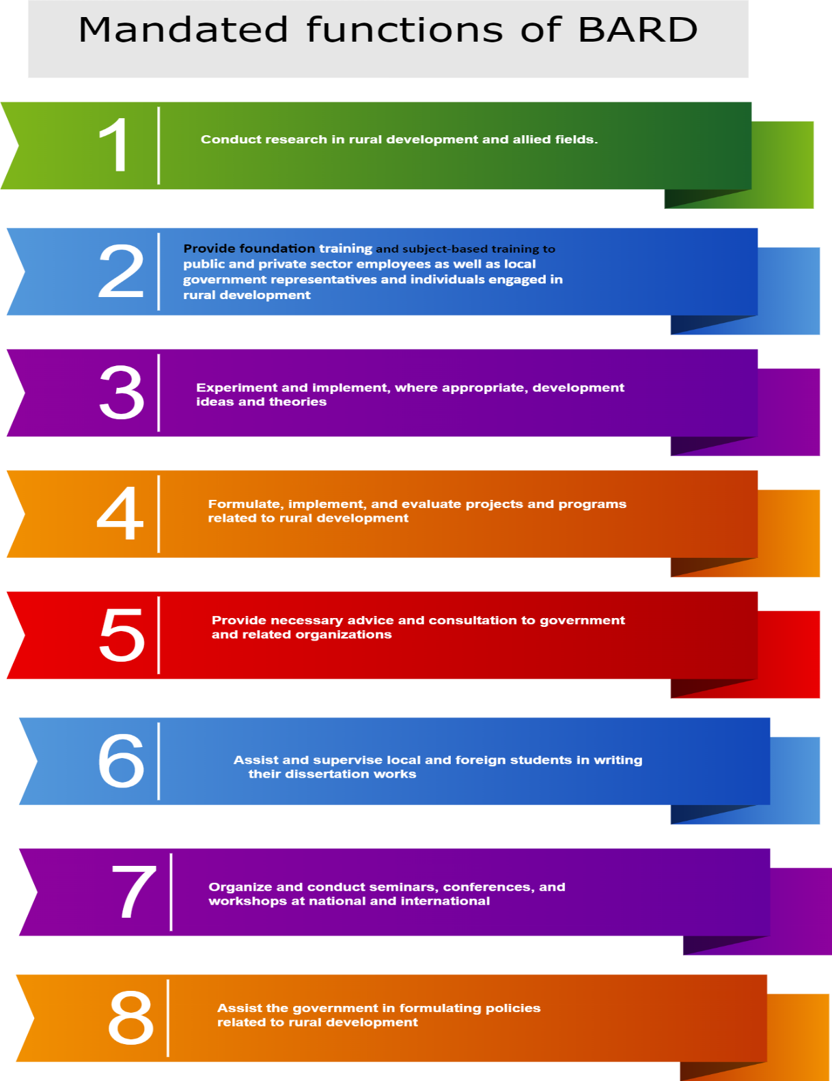

4.1.2 Academic Divisions of BARD
BARD is divided into several key areas: Agriculture and Environment, Rural Education and Social Development, Rural Administration and Local Government, Rural Sociology and Demography, and Rural Economics and Business Management. Each division focuses on enhancing specific aspects of rural development and supporting sustainable growth.
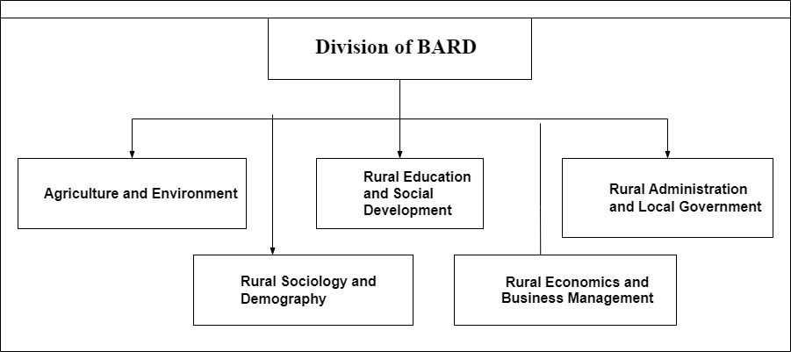

4.1.3 Organogram of BARD
BARD's organizational structure consists of a Director General (1), an Additional Director General (1), 9 Directors, 14 Joint Directors, 13 Deputy Directors, and 22 Assistant Directors, ensuring effective management and oversight.
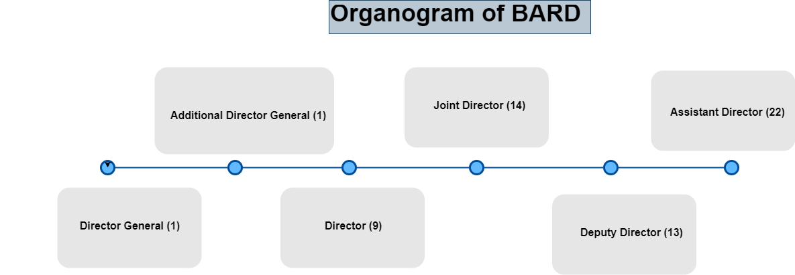

4.1.4 Service Division of BARD
BARD is organized into four key divisions: Training, Research, Action Research, and Administration. The Training division focuses on enhancing the skills of public and private sector employees and local government representatives through targeted programs. The Research division conducts studies to generate insights that inform rural development policies and programs. Action Research engages in practical investigations to address specific rural issues, collaborating with communities to implement innovative solutions. Lastly, the Administration division oversees the operational aspects of BARD, ensuring efficient coordination, budgeting, and compliance. Together, these divisions work to promote sustainable rural development initiatives.
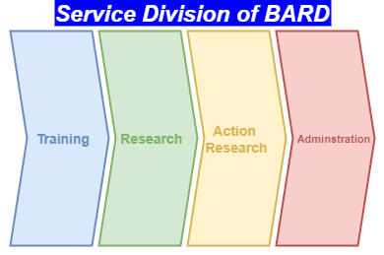

4.1.5 Functions of BARD



4.1.6 Successful Rural Development Model



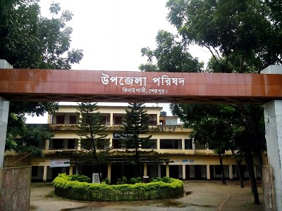
Rural Works Programme
Two-tier cooperative
Thana Irrigation Programme
Cumilla Model
Thana Training & Development Center

4.2 The Second Sessions
BARD Deputy Director Fouzia Nasreen Sultana led the second session. She presented the current initiative, the "E-Parishad Model," designed to adopt e-governance at the local government level to improve service delivery. The project aims to establish government-to-government (G2G) connectivity for data sharing and electronic exchanges among governmental entities, as well as government-to-citizen (G2C) interactions to enhance engagement between the government and the public as service recipients. In the 2019-2020 fiscal year, the E-Parishad initiative commenced two principal activities:
- Creation of Khana Profile Software with GIS Coding: This software will assist local government entities in establishing citizen databases, serving as an all-encompassing citizen registration system. It will retain pertinent information about individual residents, assisting local authorities in effective service delivery, verifying citizenship, facilitating development initiatives, monitoring SDG targets, and supplying essential data to higher authorities.

- Implementing Union Parishad administration software: This software minimizes manual processes by automating administrative operations in Union Parishads, such as staff administration, financial management, tax assessment, and collection.
The project is consistent with the government's "Digital Bangladesh" initiative, emphasizing service innovation and promoting a citizen-centric environment at the grassroots level. Local government institutions in Bangladesh have frequently faced criticism for inefficiency, insufficient citizen engagement, nepotism, and corruption. To resolve these difficulties, the government has implemented e-governance as a facet of governance innovation, modifying the Local Government Act (Union Parishad) in 2011 to incorporate requirements for e-governance.
Despite the enthusiasm of both central and local governments to adopt e-governance, local institutions face difficulties due to a lack of knowledge and abilities. E-governance entails more than mere computer utilization; it involves the application of information and communication technology (ICT) to improve government transparency, accountability, and citizen engagement, as delineated by UNESCO.
BARD's research emphasized the necessity for local organizations, such as Union Parishads, to create citizen profile databases, implement online service platforms, and enhance back-office automation for efficient service delivery. A citizen profile database offers prompt access to information for diverse services, while integrated databases are essential for efficient e-government functions.
Citizen engagement is an essential element for Union Parishads, as stipulated by the Local Government Act. Union Parishads expect citizens to participate in ward meetings and open budget talks, yet often overlook or inadequately execute these procedures. Nevertheless, the emergence of social media platforms such as Facebook has prompted individuals to engage in discussions about development issues online. Local governmental entities can utilize these platforms to engage residents in planning, development dialogues, and budgetary procedures.
BARD initiated this project to assist Union Parishads in implementing e-governance, enhancing service delivery, and promoting citizen engagement in decision-making. The initiative also facilitates the formulation of five-year plans and monitors progress toward the Sustainable Development Goal using precise data.

Chapter-05: Conclusion
Bangladesh's rural development has undergone substantial changes as a result of globalization. Globalization, currently considered both alluring and harmful, impacts numerous facets of human existence. Globalization, currently considered both alluring and harmful, impacts numerous facets of human existence. Open commerce, rapid improvements in information, and prioritizing and capitalizing on the demands and opportunities presented by globalization are crucial for addressing its challenges. Address the challenges posed by globalization by meeting its demands and seizing its opportunities. Globalization and the market economy have rapidly expanded, which has resulted in a drastic transformation of the traditional values, practices, and institutions of rural development, particularly in countries that are still in the process of growing.
BARD, which stands for the Bangladesh Academy for Rural Development, has garnered international recognition for the creative approaches it has taken to rural development in Bangladesh. Its Comilla Model of Rural Development, which is a collection of interconnected development techniques that have long-lasting effects on improving the survival and living conditions of the rural poor, is one of the most significant contributions that it has made. If one wants to communicate with Bangladesh's enormous rural population, creating opportunities for collaboration is essential. The global push towards inclusive development has led to emerging perspectives on rural development activities, their significance, and the planning procedures. In order to adjust to the ever-changing global landscape, it is very necessary to provide support for the strategic initiatives of BARD and to develop its capacity to meet the requirements of a globalized world.

Chapter-06: References
Shammi, M., Sultana, A., Hasan, N., Rahman, M. M., Islam, M. S., Bodrud-Doza, M., & Uddin, M. K. (2020). Pesticide exposures towards health and environmental hazard in Bangladesh: A case study on farmers’ perception. Journal of the Saudi Society of Agricultural Sciences, 19(2), 161-173.
https://www.academia.edu/40120696/Report_on_BARD_Tour_Bangladesh_Academy_for_Rural_Development
https://en.wikipedia.org/wiki/Bangladesh_Academy_for_Rural_Development
https://bard.gov.bd/site/page/ea1d15a9-0482-4b7f-bb53-3f295a710d7d/-
https://www.academia.edu/33226091/Bangladesh_Academy_for_Rural_Development_BARD_
https://en.wikipedia.org/wiki/Akhtar_Hameed_Khan

